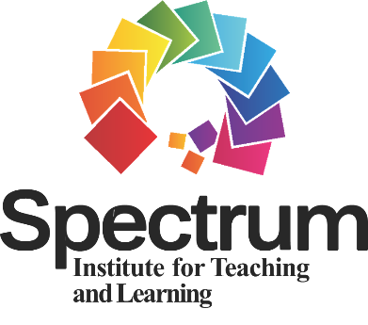
SITL RESEARCH
GRANT PROGRAM
for 2024
Application Packet

PART 1: COVER LETTER (submit as a separate word document)
Directions: Complete a 1-page cover letter in which you introduce yourself, identify the eligibility category of the grant for which you are applying, and provide a short description of your current research endeavors. It must be in 12-point Times New Roman font/type.

PART 2: APPLICATION FORM (submit as a separate word document)
Directions: Please complete items 1–4. ONLY complete item 5 if you are a master’s or doctoral degree student applicant.

1. Eligibility Category (check)
Master’s Degree Student
Doctoral Degree Student:
Award for 1 Year
Award for 3 Years
Faculty Researcher

2. Research Grant Proposal Title (10-word limit)

3. Principal Investigator/Researcher
Name:
Title:
Affiliation:
Address:
Telephone:
Email:

4. Co-Investigator(s) (provide the information below for each co-investigator)
Name:
Title:
Affiliation:
Email:

5. Faculty Advisor/Sponsor (only applicable to master/doctoral student applicant)
Name:
Title:
Affiliation:
Address:
Telephone:
Email:

PART 3: BUDGET SUMMARY (submit as a separate word document)
Directions: Please submit a summary of the anticipated expenses for the 1-year project. If applying for the 3-year project (doctoral students), submit a summary of the anticipated expenses across three years. Use 12-point Times New Roman font when typing the budget (1 page limit).

NOTE: This grant program does not allow the use of budgeted funds for indirect costs for project support.

PART 4: RESEARCH ABSTRACT (submit as a separate word document)
Directions: Please submit a research abstract (1,200-word limit not including section headings) using the section headings listed below. Use 12-point New Times Roman font/type. Single space the text and add a blank line between section headings. If applying for the 3-year project (doctoral students), submit a research abstract for each proposed study across the three years (1,500-word limit not including section headings).

Section Headings for Abstract
a. Purpose of the Research Study – Include the hypothesis and/or research question(s) as appropriate.
b. Background Literature and Theoretical Framework – Include as applicable to the research study.
c. Proposed Study Design and Methodology (participants, research design, data collection, data analysis) – Include as applicable to the study.

NOTE: While in-text citations are appropriate, do NOT include a reference list.

Evaluation of Research Abstract
The research abstract(s) will be evaluated according to the following five criteria:
(a) purpose and research questions and/or hypotheses;
(b) background literature and theoretical framework as applicable to the research study;
(c) proposed study design and methodology (participants, research design, data collection, data analysis) as applicable to the research study;
(d) potential to contribute to and/or impact Spectrum research (i.e., significance of research study to overall research specific to the Spectrum of Teaching Styles); and
(e) clarity of writing.

PART 5: QUALIFICATIONS STATEMENT (submit as a separate word document)
ONLY APPLICABLE to master/doctoral student applicants!
Directions: Please submit a 1-page statement written by your faculty advisor/sponsor on university letterhead addressing: (a) the student’s and faculty advisor/sponsor’s roles in the research study/studies; (b) how the student would make a unique contribution to research through the proposed research study/studies; and (c) the student’s capability to conduct the proposed research study/studies.

APPLICATION DUE DATE

March 30, 2024

Email all Application Packet documents to spectruminstituteboard@gmail.com.

The SITL will acknowledge the receipt of all application packet documents.

